**ICT in Support of Precision Agriculture**

**Venue & Programme**

The Summer School will take place from **26 August to 6 September 2024**. It will be held at the Faculty of Agriculture and Life Sciences, University of Maribor.

**IN-PRESENCE attendance period:** August 26 to 31, 2024

**VIRTUAL attendance period:** September 2 to 6, 2024.

**Address:** Faculty of Agriculture and Life Sciences, Pivola 10, 2311 Hoče.

**Online event:** MS Teams

**The programme** is published on the [University of Maribor Summer School website.](https://ipa.splet.arnes.si/schedule/)

During the summer school, some changes to the programme are possible.

**How to get to Maribor**



**BY AIR**

The closest airport to Maribor is the Graz Airport in Austria (about 50 km). You can also choose to fly into Ljubljana Airport, which is 140 km away from Maribor. The Zagreb Airport in Croatia is another option (about 125 km).****

**BY TRAIN**

You can reach Maribor from Ljubljana, the capital of Slovenia, in less than 2 hours. The quickest means of rail transport is the Inter City train from Ljubljana to Maribor, which runs four times a day. There are also direct daily trains to Maribor from Graz, Zagreb, Vienna and Munich.****

**BY BUS**

Maribor is directly connected with many towns in Europe. You can find more information at <https://global.flixbus.com/> and <http://www.eurolines.com/>.****

**OTHERS**

GOOPTI offers international taxi services between airports in Graz, Zagreb, Vienna, Venice… and Maribor. You can find more information on the web page: <http://www.goopti.com/>.

**Accommodation**

|  |  |  |  |
| --- | --- | --- | --- |
| Summer School | Arrival Date* | Departure Date* | Accommodation |
| ICT in Support of Precision Agriculture | 26 August 2024 | 1 September 2024 |  |

**\* The students may be allowed to stay for an additional day if necessary. You must inform us about this before arrival and wait for our confirmation.**

**Gosposvetska, dorm number 16** (address: Gosposvetska cesta 89, Maribor)  
https://sd.um.si/portal/index.php/nasi-domovi?layout=edit&id=566

You can pick up the keys to the dorm 24/7 at the reception of the dorm number 5 (address: Gosposvetska cesta 85). You need your ID.

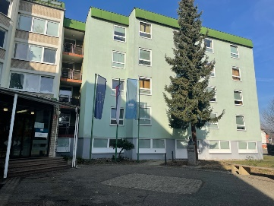

**Price**



1-week summer school programme: 100,00 EUR

**Meals**

Lunch will be served at Faculty of Agriculture and Life Sciences.

Slika, ki vsebuje besede na prostem, trava, stavba, drevo

Opis je samodejno ustvarjen

**Social programme**

**Evening and social activities**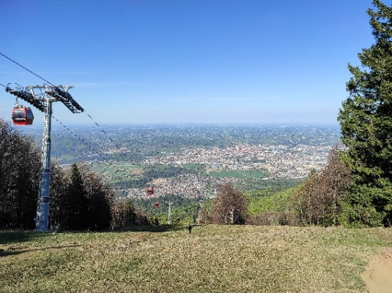

**Hiking** – Bring your sports equipment and hiking shoes.

**Ice skating** – Make sure to bring some warm clothing (a sweatshirt or jacket).





**Clothing**

Based on the programme of the summer school, we recommend you take summer clothing and some spare clothing for eventual rainy or somewhat colder days. September is usually very mild in Maribor but be prepared for one or two days below 15 degrees Celsius in the morning or at night. Please, do not forget sunscreen, as you are going to spend some time at the sunny side of the Alps.

**Welcome to Maribor!**

